

Flavors of Home: Simple Recipes for Every Occasion
COOKBOOK
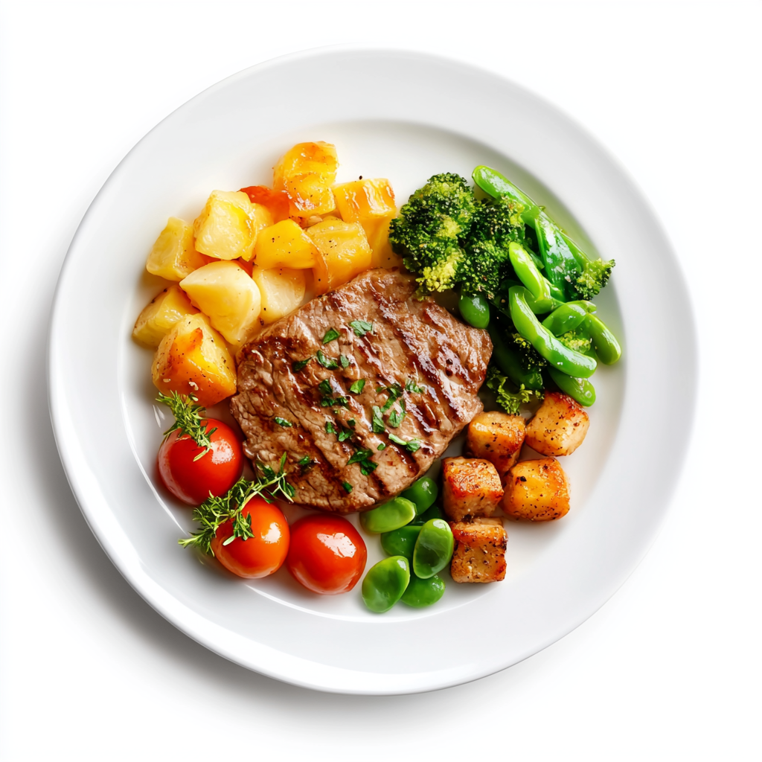

Cook. Taste. Love. Repeat.


Flavors of Home: Simple Recipes for Every Occasion
COOKBOOK

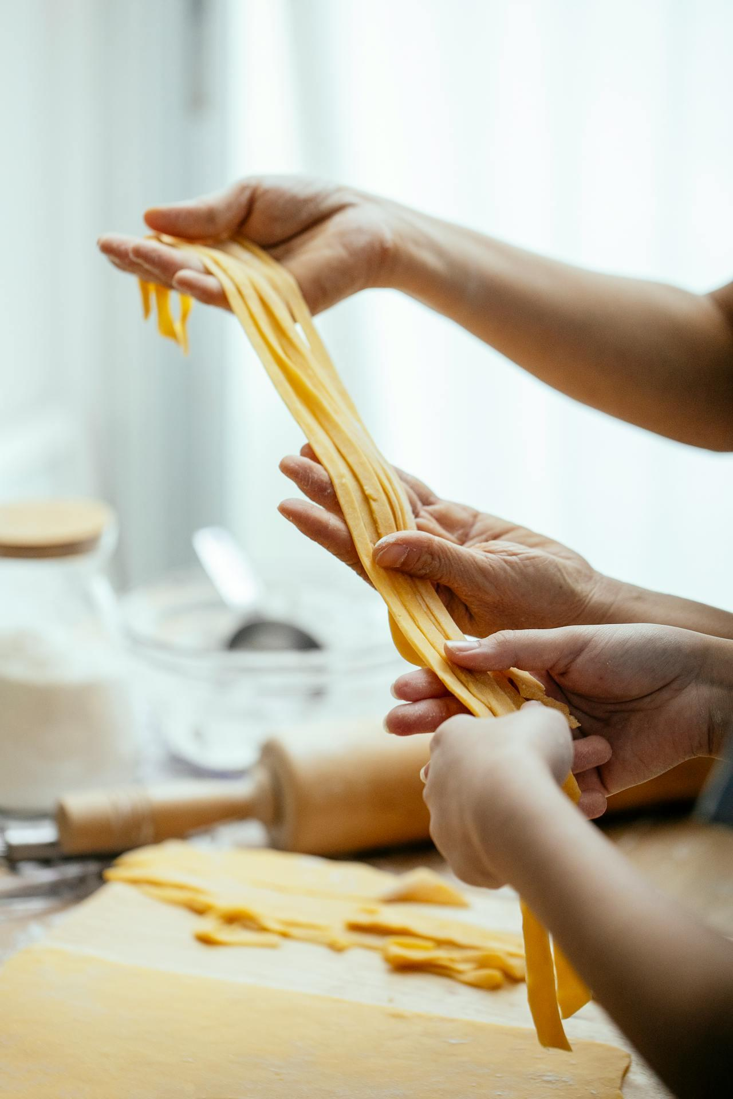

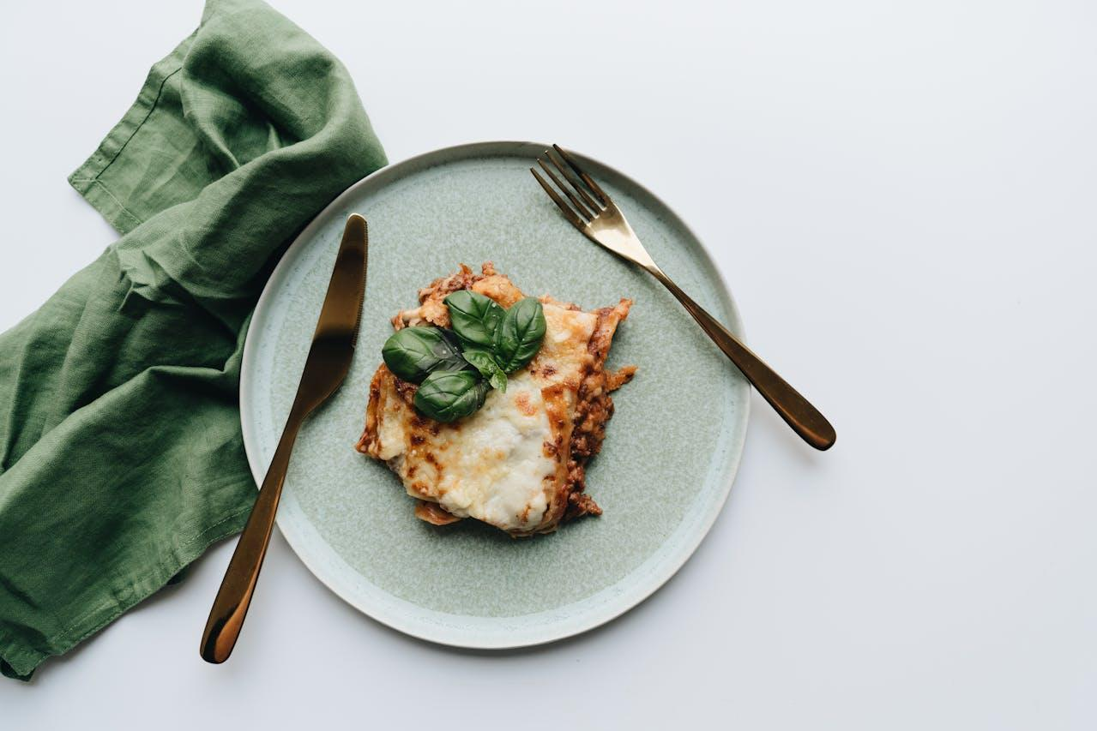

Cook. Taste. Love. Repeat.

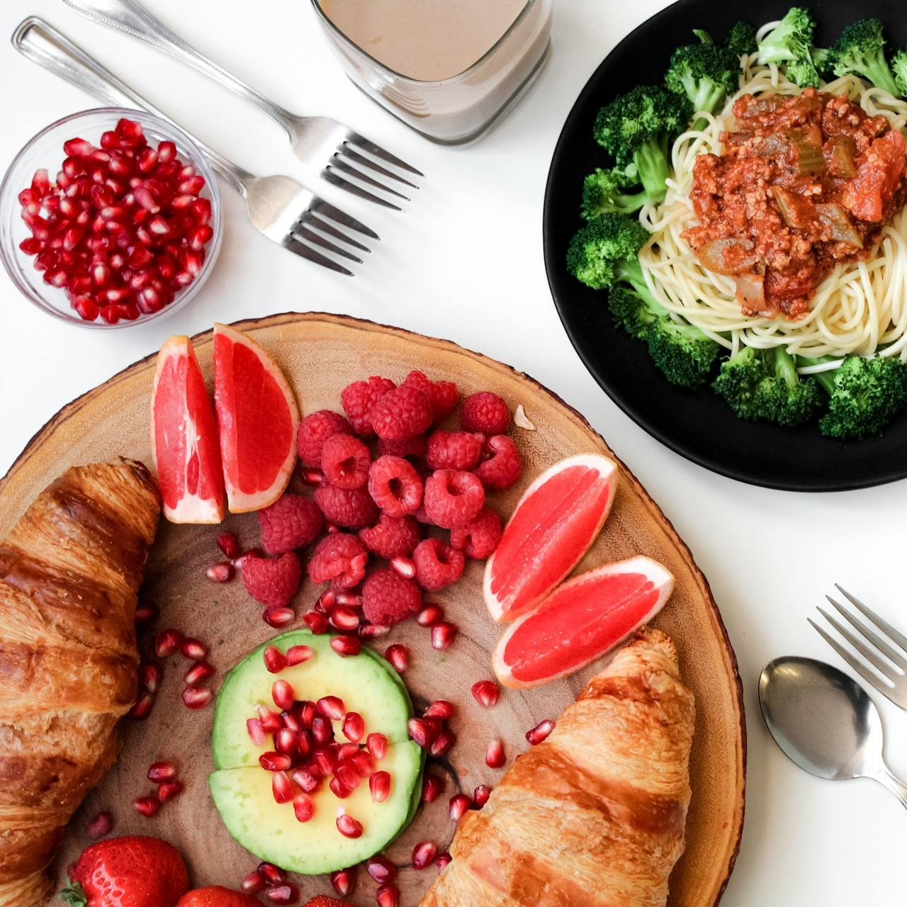

Flavors of Home: Simple Recipes for Every Occasion
COOKBOOK
_________________________

Cook. Taste. Love. Repeat.

Table of Content
- Welcome to the World of Cooking
- Essential Tools for Your Kitchen
- Welcome to the World of Cooking
- Cooking Tips and Tricks
- Fluffy Pancakes with Maple Syrup
- Classic Scrambled Eggs
- Overnight Chia Pudding
- Greek Salad with Feta and Olives
- Welcome to the World of Cooking
- Essential Tools for Your Kitchen
- Welcome to the World of Cooking
- Cooking Tips and Tricks
- Fluffy Pancakes with Maple Syrup
- Classic Scrambled Eggs
- Overnight Chia Pudding

- Greek Salad with Feta and Olives
- Essential Tools for Your Kitchen
- Welcome to the World of Cooking
- Cooking Tips and Tricks
- Fluffy Pancakes with Maple Syrup
- Classic Scrambled Eggs

Classic Spaghetti Bolognese Recipe
SUBHEADINGS FOR RECIPE INSTRUCTIONS
_________________________





PREP  15MIN | COOK  1.5 HOUR | SERVICE  4 | LEVEL  MEDIUM

INGREDIENTS  - 2 tablespoons olive oil  - 1 large onion, finely chopped  - 2 garlic cloves, minced  - 1 carrot, finely diced  - 1 celery stalk, finely diced  - 500g ground beef or pork (or a mix)  - 1 can (400g) crushed tomatoes  - 2 tablespoons tomato paste  - 1 cup beef or chicken stock  - 1 teaspoon dried oregano  - 1 teaspoon dried basil  - Salt and pepper to taste |  |  | INSTRUCTIONS  Prepare the Sauce:  Heat olive oil in a large pan  Add the onion, garlic, carrot, and celery. Cook for about 5 minutes.  Add the ground meat and cook until browned, breaking it up  Stir in the tomato paste and cook for 1 minute.  Add the crushed tomatoes, stock, oregano, basil, and sugar. Stir well.  Bring the sauce to a simmer, reduce heat to low, and cook for 20-30 minutes, stirring occasionally.  Cook the Pasta:  Add the spaghetti and cook according to the package instructions until al dente.  Drain the pasta, reserving 1/2 cup of the pasta water.  Combine and Serve:  Toss the drained spaghetti with the sauce, adding a splash of reserved pasta water if needed to loosen the sauce.  Serve immediately with grated Parmesan cheese and fresh basil leaves.
Where Every
Dish Tells
a Story

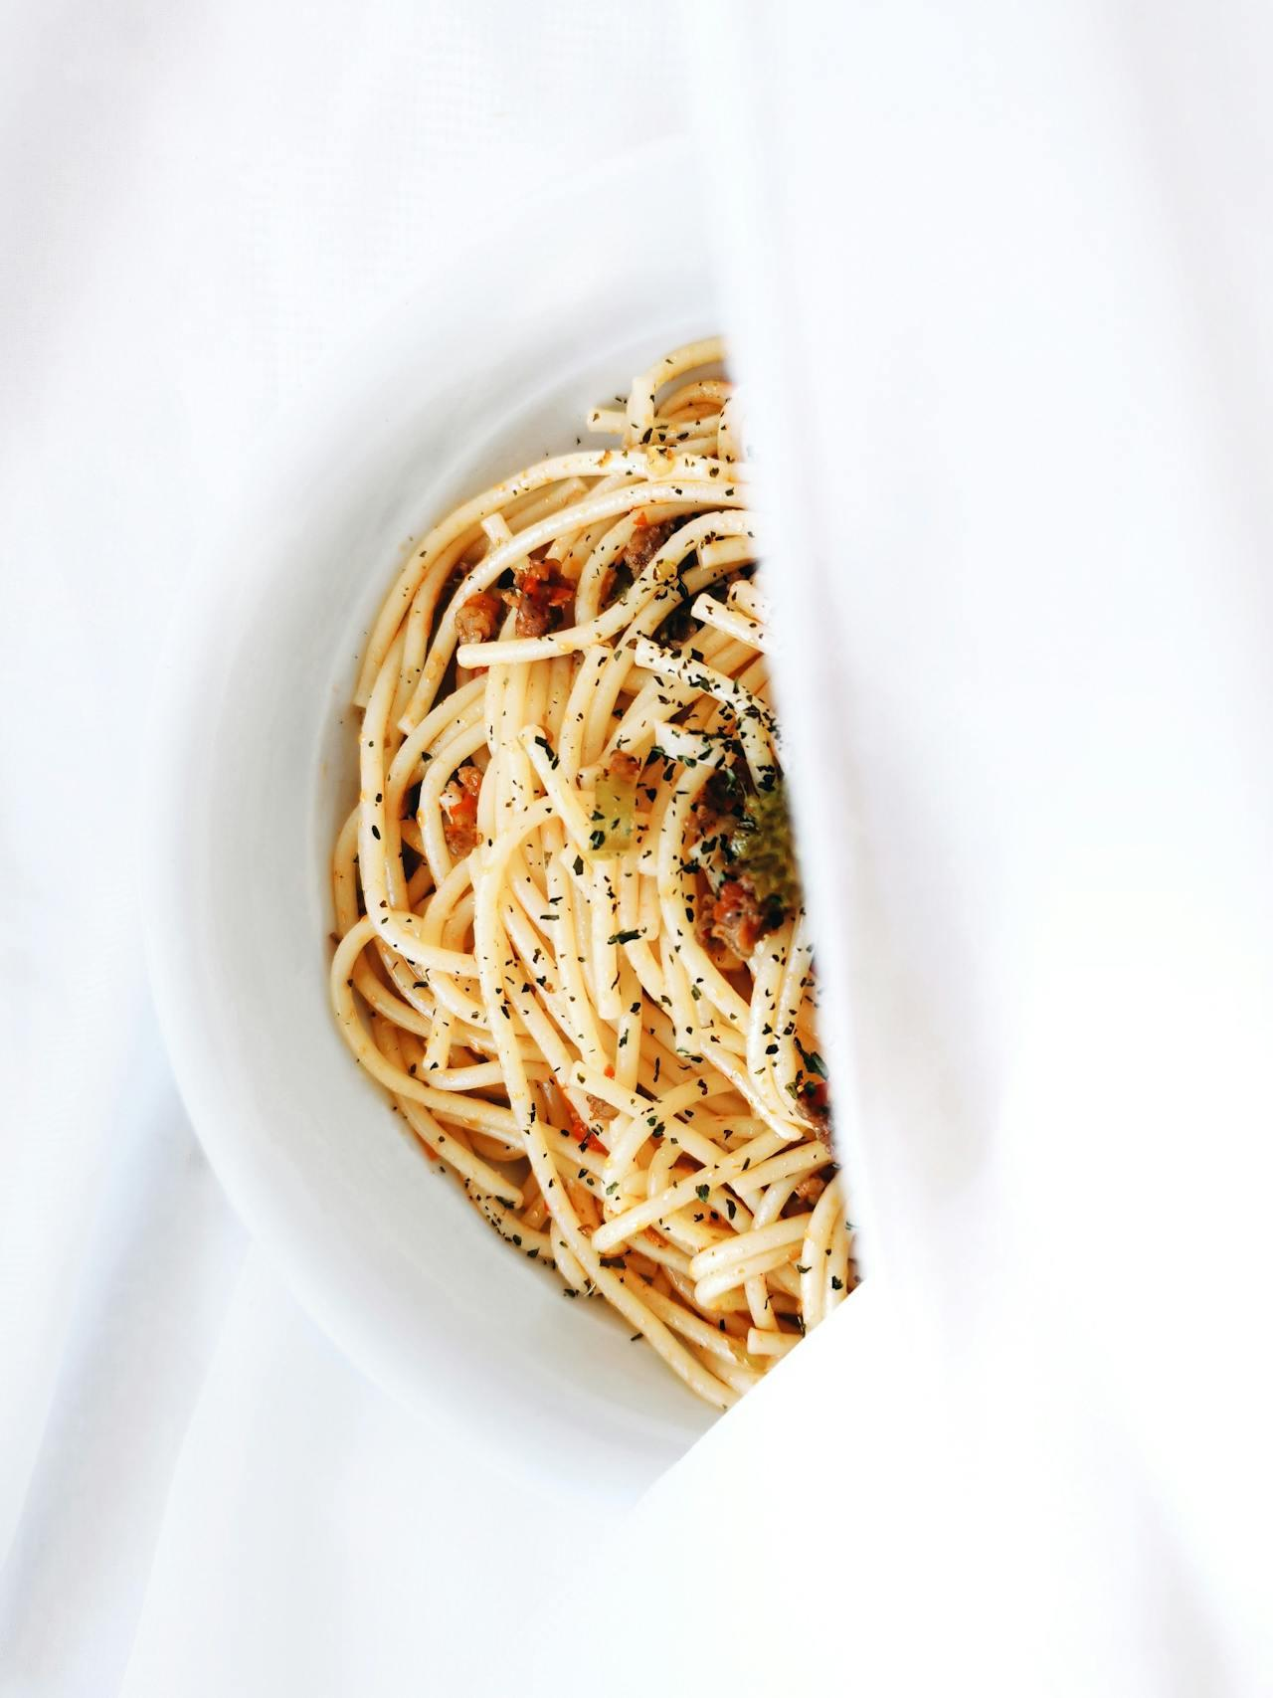

QUICK TIP
_________________________
- Vegetarian Option: Substitute ground meat with finely chopped mushrooms or lentils.
- Make It Spicy: Add a pinch of red chili flakes while sautéing the vegetables.
- Storage: Store leftover sauce in an airtight container in the fridge for up to 3 days or freeze for up to 3 months.

Avocado Toast with Poached Egg
SUBHEADINGS FOR RECIPE INSTRUCTIONS
_________________________
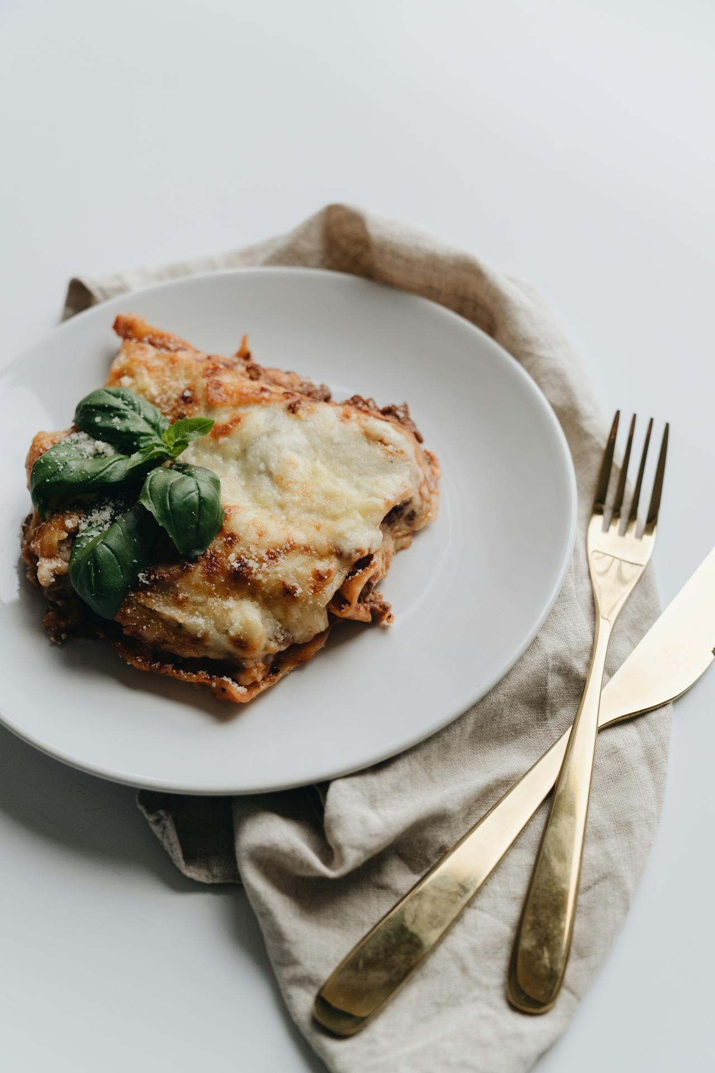
 | 
PREP  15MIN | COOK  1.5 HOUR
 | 
SERVICE  4 | LEVEL  MEDIUM

INGREDIENTS
- 2 tablespoons olive oil
- 1 large onion, finely chopped
- 2 garlic cloves, minced
- 1 carrot, finely diced
- 1 celery stalk, finely diced
- 1 can (400g) crushed tomatoes
- 2 tablespoons tomato paste
- 1 cup beef or chicken stock

INSTRUCTIONS
Heat olive oil in a large pan
Add the onion, garlic, carrot, and celery. Cook for about 5 minutes.
Add the ground meat and cook until browned, breaking it up
Stir in the tomato paste and cook for 1 minute.
Add the crushed tomatoes, stock, oregano, basil, and sugar. Stir well.
Bring the sauce to a simmer, reduce heat to low, and cook for 20-30 minutes, stirring occasionally. Add the spaghetti and cook according to the package instructions until

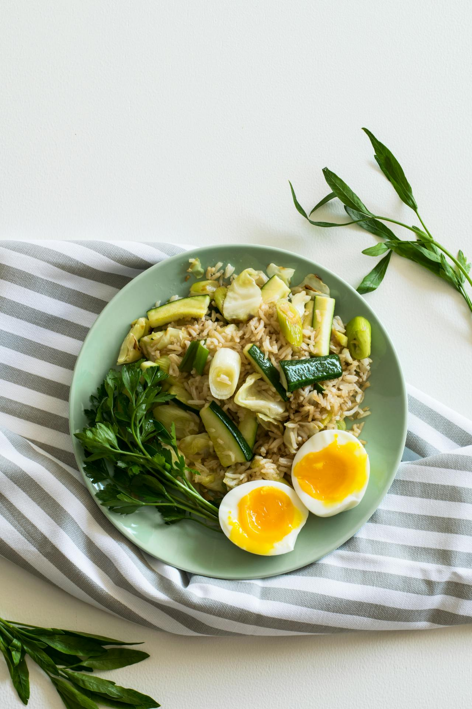
Classic Eggs Benedict
SUBHEADINGS FOR RECIPE INSTRUCTIONS
_________________________




PREP  15MIN | COOK  1.5 HOUR | SERVICE  4 | LEVEL  MEDIUM

INGREDIENTS  - 2 tablespoons olive oil  - 1 large onion, finely chopped  - 2 garlic cloves, minced  - 1 carrot, finely diced  - 1 celery stalk, finely diced  - 500g ground beef or pork (or a mix)  - 1 can (400g) crushed tomatoes  - 2 tablespoons tomato paste  - 1 cup beef or chicken stock  - 1 teaspoon dried oregano  - 1 teaspoon dried basil  - Salt and pepper to taste |  |  | INSTRUCTIONS  Prepare the Sauce:  Heat olive oil in a large pan  Add the onion, garlic, carrot, and celery. Cook for about 5 minutes.  Add the ground meat and cook until browned, breaking it up  Stir in the tomato paste and cook for 1 minute.  Add the crushed tomatoes, stock, oregano, basil, and sugar. Stir well.  Bring the sauce to a simmer, reduce heat to low, and cook for 20-30 minutes, stirring occasionally.

